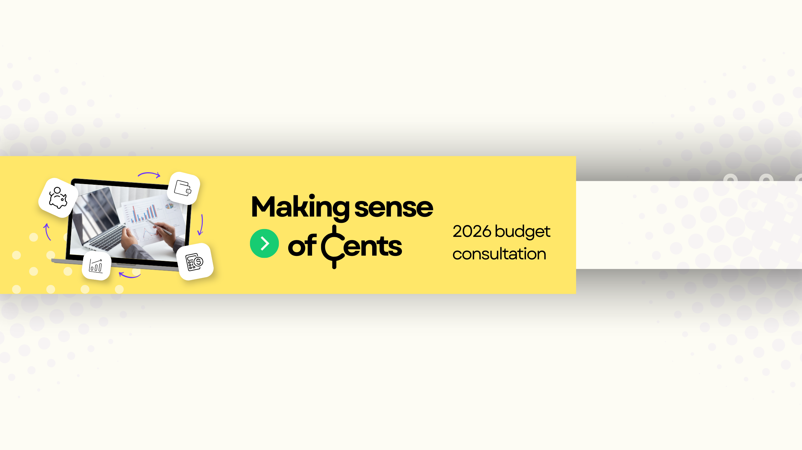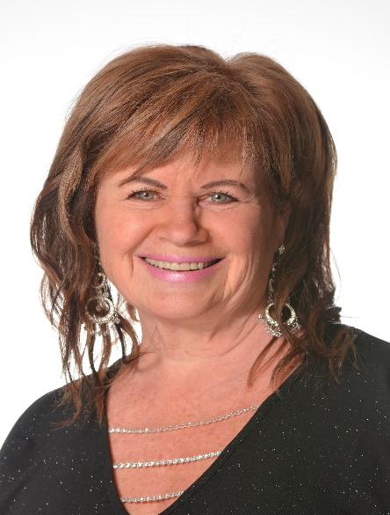
BUDGET FEEDBACK INVITED FROM RDKB AREA A DIRECTOR ALI GRIEVE
A few weeks ago, Area A residents received a letter from me asking for early feedback as we begin planning for the 2026 Budget cycle. Here’s a quick update:
In 2025, the Area A tax rate decreased by 0.55%. This reduction was the result of a 4% increase in service costs paired with a 5.19% increase in total assessed property values across the region. Since our tax rate is based on both the cost of services provided to Area A residents and the assessed value of local properties, the outcome was a lower rate per $1,000 of assessed value. We still want to hear from you!
🔹 Complete the Budget Survey
Please fill out the survey you received and return it by:
📍 Dropping it off or mailing it to the RDKB office at 843 Rossland Avenue, Trail,
OR
🌐 Filling it out online at: https://jointheconversation.rdkb.com/area-a-budget-survey
📅 Survey Deadline: January 5, 2026 at 4:30 p.m.
All responses are anonymous.
🔹 Upcoming Public Meetings
📍 Special Budget Meeting (with door prizes)
Date: November 18, 2025 Time: 6:30 p.m. Location: Fruitvale Memorial Centre
📍 Annual Town Hall Meeting (more door prizes!)
Date: February 11, 2026 Time: 6:00 p.m. Location: Fruitvale Memorial Centre
Both meetings are opportunities to discuss service delivery, taxation, and the priorities that matter most to YOU as a resident of Area A. Thank you for your ongoing input and engagement — it truly helps shape the future of our community.
🎉 Exciting Update from Beaver Valley Family Park! 🎉
We’re thrilled to announce that our brand-new Yurt is nearly complete! Thanks to the incredible efforts of our hardworking staff and a fantastic local contractor and crew, this cozy new addition is almost ready to welcome visitors.
🌿 Whether you're planning a weekend getaway, yoga class, team meeting, or just curious to check it out, you'll definitely want to visit when it opens.
📅 Stay tuned for a special ribbon-cutting ceremony coming this spring!
We can’t wait to celebrate this amazing new feature with you — another great reason to love Beaver Valley Family Park! 🏕️✨

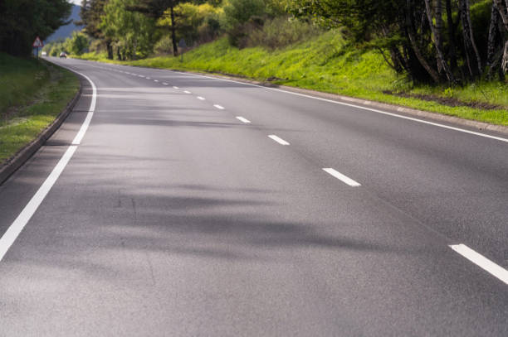
🚧 Smooth Roads in Our Rural Communities! 🚧
Big shout-out to the Ministry of Transportation and the awesome crew at YRB for all the fresh paving we've seen around our rural roads over the past couple of years! More improvements coming!
Our roads are looking better than ever, and it hasn’t gone unnoticed. WE THANK YOU!
Here’s to safer, smoother travels for everyone in the community!

